Thinking and Learning

Through
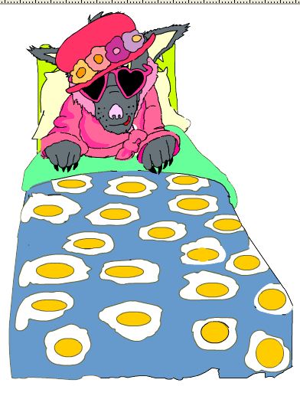
Fairy Tales

In
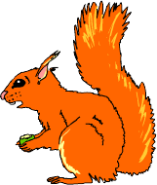



Modern Foreign Languages

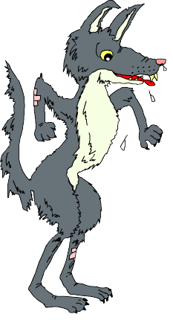

Story Boarding

Purpose | - to develop sequencing skills  - to make deductions  - to make judgements informed by reasons and evidence  - to develop language learning strategies and knowledge about language
Links to KS2 framework | - O3.1 Listen and respond to simple rhymes, stories and songs  - O3.2 Recognise and respond to sound patterns and words  - L3.1 Recognise some familiar words in written form  - O4.2 Listen for specific words and phrases  - O4.3 Listen for sounds, rhyme and rhythm  - L4.2 Follow a short familiar text, listening and reading at the same time  - L4.3 Read some familiar words and phrases aloud and pronounce them accurately
Preparation | Pupils work in groups of 3 or 4. Each group will need:  - 1 set of picture cards
Activity | - Ask pupils to sequence the cards in the order in which they appear in the story.  - Using the animated on screen version ask class to find the Spanish words for the pictures that appear on the first page. Ask them to explain their choice. Right or wrong, the reasons they give are very important as they are articulating language learning strategies. If word selected is incorrect ask class if there could be another word for the picture. Ask for reasons. Continue until correct word is identified.  - Once they have identified the words for the pictures that appear on the first page of the story, ask them to repeat the words after you. Ask them to comment on the sound and the spelling of the words – make links to phonic grid.  - Now ask them to listen to that page being read and to point to the pictures when they hear the words.  - Now remove the text and ask them to listen again to see if they can identify the words.  - Replay the first page with the text and ask them to try and join in when the word is said. Tell them that you intend to remove the text and would like them to still join in. Ask what they need to focus on to be able to do this.  Repeat for next few pages.
Debrief | Ask pupils what they discovered about language through the process and how they discovered it. What skills did they use? I.e. discussing, explaining, reasoning, justifying, making judgements etc.

 |  | 
 | 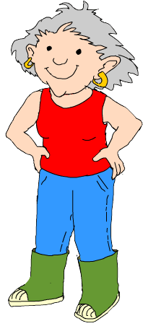
 |  |  | 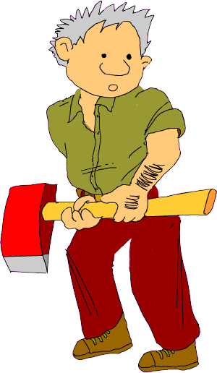

Card Sorting – Nouns 1

Purpose | - to sort, classify and group words  - to articulate precisely reasoning process  - to develop language learning strategies and knowledge about language
Links to KS2 framework | - O3.2 Recognise and respond to sound patterns and words  - L3.1 Recognise some familiar words in written form  - L3.3 Experiment with the writing of simple words  - O4.2 Listen for specific words and phrases  - L4.3 Read some familiar words and phrases aloud and pronounce them accurately
Preparation | Pupils work in groups of 3 or 4. Each group will need:  - 1 set of noun cards
Activity | - Give out the cards to each group. Say the words on each card and ask pupils to put them into the sequence as you say them. Discuss any that were difficult to identify.  - Ask pupils to sort the cards into groups.  - After 5 minutes ask each group how they chose to sort.  - Whatever way groups have sorted the words go in that direction. For example if a group has sorted into words they know and don’t know, check the meaning of the words that they think they know in the story. Listen to the pronunciation of the words and practice repeating them.  - Now look in the story to work out the meaning of the group of words they didn’t know. Listen to the sounds of the new words and practice the pronunciation.  - If they still can’t work out the meaning what other strategies do they think they could they employ?  - Ask them to choose a favourite word and to draw it in the air on the back of their partner. In pairs or groups try and guess each other’s favourite word.
Debrief | Ask pupils what they discovered about language through the process and how they discovered it. What skills did they use? I.e. discussing, explaining, reasoning, deducing, justifying etc.

Card Sorting – Nouns 2

Purpose | - to sort, classify and group words  - to articulate precisely reasoning process  - to make links between words  - to develop language learning strategies and knowledge about language
Links to KS2 framework | - O3.2 Recognise and respond to sound patterns and words  - L3.1 Recognise some familiar words in written form  - L3.3 Experiment with the writing of simple words  - O4.2 Listen for specific words and phrases  - L4.3 Read some familiar words and phrases aloud and pronounce them accurately
Preparation | Pupils work in groups of 3 or 4. Each group will need:  - 1 set of noun cards
Activity | - Give out the cards to each group. Say the words on each card and ask them to put them into the sequence as you say them. Discuss any that were difficult to identify.  - Ask pupils to sort the cards into groups.  - After 5 minutes ask each group how they chose to sort.  - Whatever way groups have sorted the words go in that direction.  - Some groups will probably sort by “el”, “la”, “los” and “las”. Ask pupils to explain what the “el”, “la”, “los” and “las” could mean and consequently to articulate precisely how they have sorted – i.e. by gender and singular/plural.  - Confirm their understanding by checking in the story. Gender is a difficult concept for English speakers, give pupils time to reflect on the concept.  - If they show interest in the gender issue, use pages 2 and 3 of the word cards, which allow them to explore the issues of gender and plurality.  - Give each group a selection of the words on pages 2 and 3. Ask pupils to make short phrases out of their words by thinking carefully about the gender. Ask them to check that each word in a phrase matches in terms of gender, singular or plural.  - Ask each group to feed back a selection of their phrases. Ask other groups to comment.
Debrief | Ask pupils what they discovered about language through the process and how they discovered it. What skills did they use? I.e. discussing, explaining, reasoning, deducing, justifying etc.

la niña | la niña | la niña | la niña | la niña | la niña
la casa | la casa | la casa | la casa | la casa | la casa
el pastel | el pastel | el pastel | el pastel | el pastel | el pastel
la bici | la bici | la bici | la bici | la bici | la bici
el lobo | el lobo | el lobo | el lobo | el lobo | el lobo
la abuela | la abuela | la abuela | la abuela | la abuela | la abuela
la cama | la cama | la cama | la cama | la cama | la cama
el ojo | el ojo | el ojo | el ojo | el ojo | el ojo
la oreja | la oreja | la oreja | la oreja | la oreja | la oreja
el diente | el diente | el diente | el diente | el diente | el diente
el saco | el saco | el saco | el saco | el saco | el saco
el leñador | el leñador | el leñador | el leñador | el leñador | el leñador

las niñas | las niñas | las niñas | las niñas | las niñas | las niñas
las casas | las casas | las casas | las casas | las casas | las casas
los pasteles | los pasteles | los pasteles | los pasteles | los pasteles | los pasteles
las bicis | las bicis | las bicis | las bicis | las bicis | las bicis
los lobos | los lobos | los lobos | los lobos | los lobos | los lobos
las abuelas | las abuelas | las abuelas | las abuelas | las abuelas | las abuelas
las camas | las camas | las camas | las camas | las camas | las camas
los ojos | los ojos | los ojos | los ojos | los ojos | los ojos
las orejas | las orejas | las orejas | las orejas | las orejas | las orejas
los dientes | los dientes | los dientes | los dientes | los dientes | los dientes
los sacos | los sacos | los sacos | los sacos | los sacos | los sacos
los leñadores | los leñadores | los leñadores | los leñadores | los leñadores | los leñadores

el | el | el | el | el | el
la | la | la | la | la | la
los | los | los | los | los | los
las | las | las | las | las | las
un | un | un | un | un | un
una | una | una | una | una | una
unos | unos | unos | unos | unos | unos
unas | unas | unas | unas | unas | unas
dos | dos | dos | dos | dos | dos
gran | gran | gran | gran | gran | gran
grande | grande | grande | grande | grande | grande
grandes | grandes | grandes | grandes | grandes | grandes

Map from Memory – Visual

Purpose | - to interpret and organise information  - to make links between words  - to look for patterns  - to develop memory strategies
Links to KS2 framework | - L3.1 Recognise some familiar words in written form  - L3.3 Experiment with the writing of simple words  - L4.1 Read and understand a range of familiar written phrases  - L4.4 Write simple words and phrases using a model and some words from memory
Preparation | Pupils work in groups of 3 or 4. Each group will need:  - A blank map  - One set of visuals  (Older children could just be given a blank sheet of A3)
Activity | - Tell pupils that there is one copy of the “map” and that they have to reproduce it, as a group, as accurately as possible.  - One member of each group comes to look at the map one at a time for 15 seconds.  - Pupils then go back to their groups and record what they can remember onto their blank map.  - Repeat above two stages for each member of the group and for as many times as you deem necessary.  - When the time is up ask groups to wander around and look at the maps produced by other groups.  - Reveal original map on power point. Ask for feedback on the activity.
Debrief | Ask pupils what strategies they employed to carry out the task. Ask them  - what they did well  - what they could do better  - what they would do differently if they were to do the activity again  What skills did they use? I.e. discussing, collaboration, listening, planning, explaining, reasoning, justifying etc.


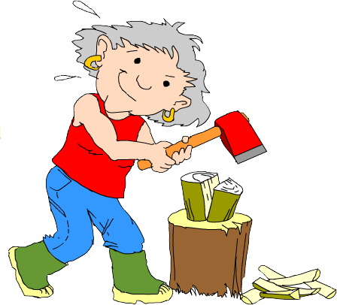
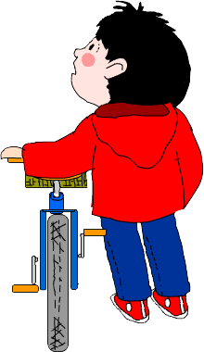



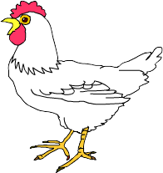
el lobo
el leñador

la casa de la abuela

el grande bosque

la abuela

Caperucita
Roja

el pájaro
Mamá y papá
el conejo

la casa de Caperucita Roja

la gallina
la ardilla
el ratón

Map from Memory – Auditory

Purpose | - to interpret and organise information  - to develop memory strategies  - to develop listening skills
Links to KS2 framework | - O3.2 Recognise and respond to sound patterns and words  - O3.4 Listen attentively and understand instructions, everyday classroom language and praise words  - L3.1 Recognise some familiar words in written form  - L3.2 Make links between some phonemes, rhymes and spellings, and read aloud familiar words  - O4.2 Listen for specific words and phrases  - O4.3 Listen for sounds, rhyme and rhythm  - L4.1 Read and understand a range of familiar written phrases  - L4.3 Read some familiar words and phrases aloud and pronounce them accurately
Preparation | Pupils work in groups of 3 or 4. Each group will need:  - 1 set of phrase cards
Activity | - Give one set of cards to each group of pupils. Read the phrases aloud and ask pupils to sequence in the order in which they hear them.  - Now ask pupils to set cards upside down on the table.  - Each pupil takes it in turns to turn up a card and to read it aloud in Spanish.  - Explain that one person from each group will come and hear the phrases being read through once.  - They will return to their group and begin the process of sequencing the phrases in the order in which they were read.  - Each member of the group has an opportunity to come out and listen to the phrases.  ( Any page from the story can be used for this activity)
Debrief | Ask pupils what strategies they employed to carry out the task. Ask them  - what they did well  - what they could do better  - what they would do differently if they were to do the activity again  What skills did they use? I.e. discussing, collaboration, listening, planning, explaining, reasoning, justifying etc.

Había una vez | una niña pequeña
que se llamaba Caperucita Roja | porque llevaba siempre
una capa muy bonita | de color rojo.
Vivía con sus padres | en una casa bonita
al borde de | un gran bosque.
Le gustaba | ir al bosque
en bici.

Había una vez | una niña pequeña
que se llamaba Caperucita Roja | porque llevaba siempre
una capa muy bonita | de color rojo.
Vivía con sus padres | en una casa bonita
al borde de | un gran bosque.
Le gustaba | ir al bosque
en bici.

Fortune Line

Purpose | - to interpret information and organise it  - to make links between pieces of information  - to formulate, explain and justify opinions  - to empathise with characters in the story
Links to KS2 framework | - O3.2 Recognise and respond to sound patterns and words  - O3.4 Listen attentively and understand instructions, everyday classroom language and praise words  - L3.1 Recognise some familiar words in written form  - L3.2 Make links between some phonemes, rhymes and spellings and read aloud familiar words  - O4.2 Listen for specific words and phrases  - L4.1 Read and understand a range of familiar written phrases  - L4.2 Follow a short familiar text, listening and reading at the same time  - L4.3 Read some familiar words and phrases aloud and pronounce them accurately
Preparation | Pupils work in groups of 3 or 4. Each group will need:  - 1 fortune line graph  - 1 set of phrases  - 1 non permanent marker
Activity | - Give out the phrase cards.  - Ask pupils to sequence phrases in the order in which you say them. Repeating them after you.  - Now ask them to re-order them in the order of the original story. Give pupils a blank copy of the graph.  - Ask pupils to place each slip in order along the bottom of the graph, matching the text to the picture, reading the phrase aloud as they do so.  - Ask pupils to decide how Little Red Riding Hood feels at each stage and to mark a point on the graph to represent her feelings.  - Ask pupils to wander around and look at each of the other graphs.  - Ask each group to feed back by describing its line and explaining its decisions.  - Pupils could plot another line to represent how the wolf felt at each stage.
Debrief | Ask pupils how they came to an agreement on where to plot their lines. What skills did they use? I.e. listening, discussing, explaining, reasoning, justifying etc.

☺

😐

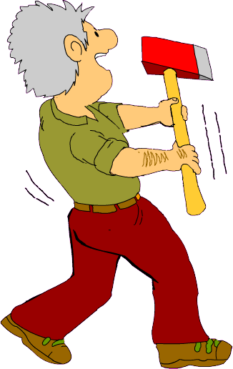


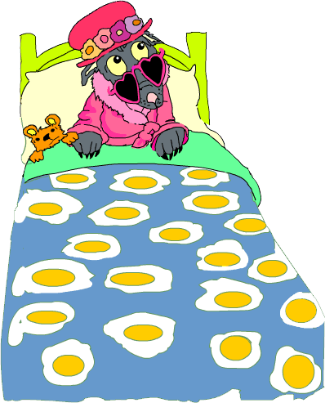
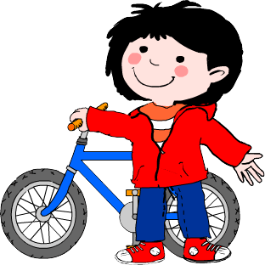
☹

Caperucita Roja

C | Caperucita Roja fue en su bici. | C | Caperucita Roja fue en su bici.
F | De repente apareció un lobo grande. | F | De repente apareció un lobo grande.
A | Caperucita Roja llamó a la puerta. | A | Caperucita Roja llamó a la puerta.
D | “Abuela, que ojos tan grandes tienes.” | D | “Abuela, que ojos tan grandes tienes.”
G | “¡Socorro!” gritó muy fuerte. | G | “¡Socorro!” gritó muy fuerte.
B | El leñador corrió a buscar al lobo. | B | El leñador corrió a buscar al lobo.
E | Comieron bocadillos y todos los pasteles. | E | Comieron bocadillos y todos los pasteles.

C | Caperucita Roja fue en su bici. | C | Caperucita Roja fue en su bici.
F | De repente apareció un lobo grande. | F | De repente apareció un lobo grande.
A | Caperucita Roja llamó a la puerta. | A | Caperucita Roja llamó a la puerta.
D | “Abuela, que ojos tan grandes tienes.”. | D | “Abuela, que ojos tan grandes tienes.”.
G | “¡Socorro!” gritó muy fuerte. | G | “¡Socorro!” gritó muy fuerte.
B | El leñador corrió a buscar al lobo. | B | El leñador corrió a buscar al lobo.
E | Comieron bocadillos y todos los pasteles. | E | Comieron bocadillos y todos los pasteles.

Kim’s Game

Purpose | - to identify strategies for memorising
Links to KS2 framework | - O3.2 Recognise and respond to sound patterns and words  - O4.3 Listen for specific words and phrases
Preparation | A basket containing about 10 items relating to the fairy tale. These could be:  A cake A flower  A red cloak A bottle of water  A cuddly wolf A sack  A toy bike A pair of glasses  A tree A sandwich
Activity | - Tell pupils that you are going to place some items on the table and then cover them up.  - Tell class that you would like them to try and remember the objects.  - Take out the objects one at a time. It can be useful to say the name of the object, and add an appropriate action before placing it on the table. This often becomes part of the memorisation process for different types of learners.  - Give about 30 seconds for looking at all the objects together on the table, then cover up or put away.  - Give pupils about a minute to recall as many objects as possible. Note: do not tell them how this should be done. They often assume that it must be done alone – if they choose to work with someone else do not stop them.
Debrief | Ask pupils what strategies they used to remember the objects. Write the various strategies on the board. Discuss the nature of the different strategies and what it would be like to adopt a different one.

Odd One Out

Purpose | - to identify similarities and differences  - to promote understanding of properties and attributes of words  - to develop reasoning skills and knowledge about language
Links to KS2 framework | - O3.2 Recognise and respond to sound patterns and words  - L3.1 Recognise some familiar words in written form  - L3.2 Make links between some phonemes, rhymes and spellings, and read aloud familiar words  - L3.2 Experiment with the writing of simple words  - L4.3 Read some familiar words and phrases aloud and pronounce them accurately
Preparation | Pupils work in groups of 2 or 3. Each group will need:  - 1 odd one out grid
Activity | - Read out the words in each column for number 1. Ask pupils to repeat.  - Ask pupils to choose an odd one out and to explain their choice (say why…). Emphasise that there are no right or wrong answers, but that all answers must be explained.  - Ask them to write down their explanation in English.  - Repeat for each numbered line.  - Ask one group to read out words in the first line from the power point. Ask them to feed back on their choice of Odd One Out.  - Ask other groups for comments.  - Repeat the process for the other lines.  - When all the lines are completed ask groups to make up their own odd one outs using words or phrases from the story.
Debrief | Ask pupils what knowledge about language they discovered during the activity. Ask them how they discovered it. What skills did they use? I.e. discussing, explaining, reasoning, justifying etc.

Odd One Out

Find and circle the odd one out on each line and explain your choice.

 | A | B | C | D |  | Why?
1 | pequeño | bonito | malo | grande

2 | Caperucita Roja | el lobo | la abuela | el leñador

3 | una casa | un bosque | un jardín | un árbol

4 | el camino | delicioso | raro | extraño

5 | los ojos | las orejas | los dientes | la nariz

6 | enfadado | enfermo | contento | miedo

7 | los pasteles | los bocadillos | el café | los caramelos

Now make up your own.

 | A | B | C | D |  | Why?
1

2

3

4

Dominoes

Purpose | - to sort words  - to make connections  - to develop memory skills
Links to KS2 framework | - O3.2 Recognise and respond to sound patterns and words  - O3.3 Perform simple communicative tasks using single words, phrases and short sentences  - L3.1 Recognise some familiar words in written form  - L3.2 Make links between some phonemes, rhymes and spellings, and read aloud familiar words  - O4.2 Listen for specific words and phrases  - O4.3 Listen for sounds, rhyme and rhythm  - L4.2 Follow a short familiar text, listening and reading at the same time  - L4.3 Read some familiar words and phrases aloud and pronounce them accurately
Preparation | Pupils work in groups of 3 or 4. Each group will need:  - 1 set of dominoes
Activity | - ask the class to distribute the dominoes equally among group members  - pupil with * * * places his card on the table saying the Spanish word aloud  - continue as game of dominoes ensuring that the Spanish words are said aloud.  - Continue until final * * * card is laid
Debrief | Ask pupils what they skills they employed during the game. i.e. listening, memorising, reasoning. Ask if they learned any new words. How did they learn them?

* * *  Caperucita Roja | little |  | una bici | red

una niña | throat |  | la garganta | pretty

una casa | voice |  | un lobo | once upon  a time

una torta | strange |  | una cama | happy

una abuela | teeth |  | un saco | El fin  * * *

los ojos | woodcutter |  | un leñador | cake

los dientes | sack |  | una puerta | sick

las orejas | door |  | una voz | big

pequeño | bed |  | grande | grandma

bonito | ears |  | malo | bike

Había una vez | girl |  | contento | eyes

roja | house |  | extraño | wolf

Pass the Parcel

Purpose | - to sort, classify and group words  - to make connections  - to process information
Links to KS2 framework | - O3.1 Listen and respond to simple rhymes, stories and songs  - O3.2 Recognise and respond to sound patterns and words  - L3.1 Recognise some familiar words in written form  - L3.2 Make links between some phonemes, rhymes and spellings, and read aloud familiar words  - O4.2 Listen for specific words and phrases  - O4.3 Listen for sounds, rhyme and rhythm  - L4.2 Follow a short familiar text, listening and reading at the same time  - L4.3 Read some familiar words and phrases aloud and pronounce them accurately
Preparation | - Children sit in groups of six (maximum)  - Each group has one bag of word or phrase cards  - music  The bag contains either single words which make up a sentence from the story, OR sentences from one page of the story.
Activity | - When music starts pupils pass round the bag  - When the music stops, the child holding the bag picks out a word or phrase and places it in the middle of the circle  - The child or the group then says the word or phrase aloud  - When all of the words or phrases have been removed from the bag, the group works together to place them in the correct order.  - The group then reads the sentence or paragraph to the rest of the class.  If you have a large class with lots of groups, you could aim to piece together all of the words in a page, or all of the sentences in the story and finally work out the overall order as a class!
Debrief | Ask pupils what skills and dispositions they used during the activity. i.e. taking turns, being fair, reasoning

Había | una | vez | una | niña | pequeña
que | se | llamaba | Caperucita | Roja.
Vivía | con | sus | padres | en | una
casa | bonita | al | borde | de | un
gran | bosque.
Había | una | vez | una | niña | pequeña
que | se | llamaba | Caperucita | Roja.
Vivía | con | sus | padres | en | una
casa | bonita | al | borde | de | un
gran | bosque.

Snakes and Ladders

Purpose | - to make connections  - to take turns  - to process information
Links to KS2 framework | - O3.3 Perform simple communicative tasks using single words, phrases and short sentences  - O4.4 Ask and answer questions on several topics
Preparation | - Children sit in groups of three or four. Each group has  - One snakes and ladders board  - One set of counters and dice  - One set of questions
Activity | Pupils take it in turns to throw the dice.  If pupils land on a red square, they climb up the ladder, if they land on a blue square, they slide down the snake.  Each time the pupil rolls the dice, they move that number of places and answer a question about the story.  The questions can be altered depending on class ability:
Debrief | Ask pupils what skills and dispositions they used during the activity. i.e. taking turns, being fair, reasoning

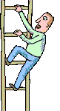  25 | 26 | 27 | 28 | 29 | 30
24 | 23 | 22 | 21 | 20 | 19
13 | 14 | 15 | 16 | 17 | 18
12 | 11 | 10 | 9 | 8 | 7
1 | 2 | 3 | 4 | 5 | 6

What is ‘hungry’ in Spanish?
How do you say ‘Wolf’ in Spanish?
What did mum bake for Grandma?
Complete the sentence. ‘a la bici se le pinchó ___ ______’
Can you name three characters from the story?
What is ‘house’ in Spanish?
Can you say ‘eyes’ and ‘teeth’ in Spanish?
What is the Spanish name for a ‘wood’?
How do the Spanish say ‘to eat’?
What does the wolf put Grandma in? Say it in Spanish!
What ‘V’ does the wolf have that is strange?

‘Que ojos tan grandes tienes’ What is Little Red Riding Hood saying ?
What is missing here?
Ojos. Orejas. _________
What does Little Red Riding Hood shout for help?
What P does Little Red Riding Hood wash?
Can you remember what ‘hacha’ is?
What Spanish word describes Little Red Riding Hood’s transport through the forest?
How do you say ‘ill’ in Spanish?
Can you name an animal from the story?
What does Little Red Riding Hood call her Grandma?

Pairs

Purpose | - to make connections  - to take turns  - to develop spontaneous talk
Links to KS2 framework | - O3.3 Perform simple communicative tasks using single words, phrases and short sentences  - O4.2 Listen for specific words and phrases  - L4.3 Read some familiar words and phrases aloud and pronounce them accurately
Preparation | - Children sit in groups of three or four. Each group has  - one set of cards
Activity | Pupils place all the cards face down on the table.  Each one takes a turn to turn two cards upright and say the words in Spanish. If the cards match they keep the pair.  To develop speaking skills the pupils can say in Spanish before turning over the cards “I think it is …” The others in the group can respond “yes, you’re right” or “no, you’re wrong”.
Debrief | Ask pupils what skills and dispositions they used during the activity. i.e. taking turns, being fair, reasoning

le chat
el gato

Caperucita Roja
el lobo

la
abuela

la mamá

el
leñador

la mamá
y
el papá
el conejo
el
ratón

Action Charades

Purpose | - to make connections  - to develop listening skills  - to develop memory skills
Links to KS2 framework | - O3.2 Recognise and respond to sound patterns and words  - O3.4 Use physical response, mime and gesture to convey meaning and show understanding  - L3.1 Recognise some familiar words in written form  - L3.2 Make links between some phonemes, rhymes and spellings, and read aloud familiar words  - O4.2 Listen for specific words and phrases using physical response to show recognition and understanding  - O4.3 Listen for sounds, rhyme and rhythm
Preparation | Pupils work in groups of 3 or 4. Each group will need:  - 1 set of charade cards  It is advisable to demonstrate activity with whole class initially
Activity | - Demonstrate the first sentence by reading it out and asking pupils to suggest an appropriate mime. Practise repetition of phrase.  - Continue to read out the other sentences allowing the children to demonstrate their understanding by miming.  - Give each group a set of charade cards and ask them to place them face down on the table.  - Each pupil takes one card in term and reads the phrase. The group mime accordingly.  - After each phrase has been mimed, repeat the previous activity but this time the pupil with the card mimes the action while the rest of the group guess the complete phrase.  - They also need to establish the character by asking in Spanish “Are you the wolf?” etc
Debrief | Ask pupils what they learned about the language through the process. What skills and dispositions did they use? I.e. listening, turn taking etc.

La madre hizo unos pasteles.
Caperucita Roja fue en su bici.
Caperucita Roja tuvo que caminar.
El lobo tenía hambre.
El lobo decidió correr lo más rápido posible a casa de la abuela.
La abuela estaba fuera en el jardín, cortando leña.
El lobo metió a la abuela dentro un saco.
Caperucita Roja llamó a la puerta.
Caperucita Roja abrió la puerta.
¡Que ojos tan grandes tienes!
¡Que orejas tan grandes tienes!
¡Que dientes tan grandes tienes!
¡El lobo saltó fuera de la cama!
Caperucita Roja tuvo miedo.
Caperucita gritó “¡Socorro!”
El leñador cojió su hacha.
“¡Te voy a matar!”
Comieron bocadillos.
Tomaron una buena taza de café.
Caperucita lavó los platos.
Juan cortó la leña.
La abuela reparó la bici.
¡El lobo estaba justo detrás de...Tí!
El lobo prefiere hamburguesas.

Happy Families

Purpose | - to make connections  - to take turns  - to develop spontaneous talk
Links to KS2 framework | - O3.3 Perform simple communicative tasks using single words, phrases and short sentences  - O4.2 Listen for specific words and phrases  - L4.3 Read some familiar words and phrases aloud and pronounce them accurately
Preparation | - Children sit in groups of three or four. Each group has  - One set of cards
Activity | Cards are distributed evenly among the group – they count out cards in Spanish as they are distributed. The aim of the game is to collect families by colour.  Taking turns one pupil asks the person next to him/her for a card that they want in Spanish.  If their neighbour has the card he has to hand it over saying “yes, I have it” or “no, I haven’t got it” in Spanish.  Each group member takes it in turn to ask for a card.
Debrief | Ask pupils what skills and dispositions they used during the activity. i.e. taking turns, being fair, reasoning


Caperucita Roja
el leñador
la abuela

el gato
el lobo
la Mamá


el papá
el conejo
el ratón
Caperucita Roja

el leñador

la abuela

el gato

el lobo

la Mamá

el papá

el conejo

el ratón

Caperucita Roja

el leñador

la abuela

el gato

el lobo

la Mamá

el papá

el conejo

el ratón

Caperucita Roja

el leñador

la abuela

el gato

el lobo

la Mamá

el papá

el conejo

el ratón

Caperucita Roja

el leñador

la abuela

el gato

el lobo

la Mamá

el papá

el conejo

el ratón

Blockbusters

Purpose | - to make connections  - to solve problems
Links to KS2 framework | - O3.3 .Perform simple communicative tasks using single words, phrases and short sentences  - O4.4 Ask and answer questions on several topics
Preparation | Cut up the lettered hexagons  Pupils work in groups of 3. One group member asks the questions, the other two play against each other. Each group will need:  - 1 blockbusters board  - 1 set of questions  - Set of counters (about 20)  Pupils must try to get from the left to the right side of the game board, by matching the revealed initials to vocabulary from the story of Petit Chaperon Rouge, marking their route with counters.
Activity | The Rules:  - Pupils place the hexagons with the capital letters face down on each game board hexagon. Any random order can be chosen.  - Pupils must then choose a hexagon from the left side of the board, taking turns to play.  - After the first go, pupils can only choose hexagons that touch an answered shape.  - As the capital letters are revealed in each hexagon, the pupil must answer a matching question from the question sheet.  - If the question is answered correctly, the child can claim the shape as theirs, by putting one of their coloured counters on the shape.  - If the question is incorrectly answered the shape is left blank. The other pupil may not use that space either.
Debrief | Ask pupils what they learned and how they learned it. What skills did they use? I.e. listening, reasoning, etc. What dispositions did they need? i.e. turn taking.

CR
L
L
M
B
D
A
P
C
L
H
B
N
J
P
C
G
S
O
OR
S
P

CR What CR wears red?
L Which L is after a little girl?
L Which L saves the day?
M Which M has a little girl?
B What B has a puncture?
A What A has a visit from her grand-daughter?
P What P can be eaten?
C What C is a bunny?
L What L gets chopped up in the story?
H What H makes your tummy rumble?
B Which B has two wheels and a handlebar?
N Which N means girl?
G What G sounds sore?
P What P has a little girl?
J What J has grass and flowers in it?
S Which S was grandma put in?
O What O do we need to see?
OR What OR helps us hear?
D Which D do we brush with toothpaste?
S What S do we shout when in trouble?
C What C means to eat?
P What P gets washed after a meal?

MFL KS2 Framework for year 4

Pupils should have opportunities

 | Oracy |  | Literacy |  | Intercultural Understanding | Knowledge about Language | Language Learning Strategies
O4.1 | To memorise and recite a short text  - Learn finger rhymes, poems or short stories or a non-fiction text | L4.1 | To read and understand a range of familiar written phrases  - Match phrases and short sentences to picture or topics | IU4.1 | To learn about festivals and celebrations in different cultures  - Learn how children of different cultures celebrate special days  - Identify similarities and differences  - Learn simple phrases to celebrate festivals | Reinforce and extend recognition of word classes and understand their function  Recognise and apply simple agreements, singular and plural  Apply question forms  Develop awareness of communication strategies  Recognise that texts in different languages will often have the same conventions of style and layout  Apply phonic knowledge of the foreign language to support reading and writing  Identify a different writing system | Discuss language learning and reflect and share ideas and experiences  Use actions and rhymes to aid memorisation  Ask for repetition and clarification  Use context and previous knowledge to help understanding  Practice new language – speaking aloud or silently, speaking with a friend  Practice new language outside the classroom  Plan and prepare for a language activity  Read and memorise words  Use a mental association to help remember words  Sort words into categories  Apply knowledge about letters and simple grammatical knowledge to experiment  Use context and previous knowledge to determine meaning and pronunciation
O4.2 | To listen for specific words and phrases in a song, poem or story  - Listen with care  - Use physical response to show recognition and understanding of key words and phrases  - Look carefully at the person who is speaking | L4.2 | To follow a short familiar text, listening and reading at the same time and them read part of the text aloud  - Make links between the spoken and written words  - Identify common spelling patterns in letter strings  - Pronounce letter strings, words and phrases accurately with good accent | IC4.2 | To know about some aspects of everyday culture and compare them to their own:  - To learn and compare pastimes of children of different cultures
O4.3 | To listen for sounds, rhyme and rhythm | L4.3 | To read some familiar words and phrases aloud and pronounce them accurately  - Use words which they practice on a regular basis, e.g. numbers, days, weather | IU4.3 | To compare traditional stories  - Compare characteristics of simple stories between cultures  - Learn about aspects of the writing system of a different language
O4.4 | To ask and answer questions on several topics  - Ask how to say something in the target language  - Ask someone to clarify or repeat  - Speak clearly and confidently | L4.4 | To write simple words and phrases using a model and some words from memory | IU4.4 | To learn about ways of travelling to the target country / countries  - Revise location of country / countries where target language is spoken  - Identify route from own locality to specified destination

MFL KS2 Framework for year 3
Pupils should have opportunities

 | Oracy |  | Literacy |  | Intercultural Understanding | Knowledge about Language | Language Learning Strategies
O3.1 | To listen and respond to simple stories, finger rhymes and songs  - Identify rhyming words  - Perform finger rhymes and sing songs  - Listen to stories  - Join in with storytelling | L3.1 | To recognise some familiar words in written form  - Understand words displayed in the classroom  - Identify and read short simple words when listening to familiar rhymes or stories or songs  - Read short messages | IU3.1 | To learn about the different languages spoken by children in the school  - Be aware of linguistic and cultural diversity | Identify specific sounds, phonemes and words, linking sounds to meanings  Imitate pronunciation of sounds  Hear main word classes  Recognise questions and negatives  Recognise how sounds are represented in written form  Notice the spelling of familiar words  Recognise that languages describe familiar things differently  Recognise the centrality of language in communication  Recognise different language conventions to express politeness | Discuss language learning and reflect and share ideas and experiences  Use actions and rhymes to aid memorisation  Ask for repetition and clarification  Use context and previous knowledge to help understanding  Practise new language – speaking aloud or silently, speaking with a friend  Practise new language outside the classroom  Look at the face of the person speaking and listen attentively  Use gestures and mime to show understanding  Play games to help memorisation  Recognise words which the teacher mouths silently
O3.2 | To recognise and respond to sound patterns and words  - Listen with care  - Identify sounds which are the same as or different from English  - Speak clearly and confidently | L3.2 | To make links between some sounds, rhymes and spellings and read aloud familiar words  - Identify characters and letter strings which are the same as or different to English  - Pronounce accurately the most commonly used characters and letter strings  - Read aloud a familiar sentence, rhyme or poem | IC3.2 | To locate country / countries where the language to be studied is spoken:  - Identify some of the countries where the language is spoken  - Know some facts about one country where the target language is spoken, e.g. climate, main towns, famous landmarks, produce
O3.3 | To perform simple communicative tasks using single words, phrases and short sentences  - Remember, retain and recall vocabulary  - Ask and answer questions | L3.3 | To experiment with the writing of short words  - Copy simple, familiar words using a model  - Write some single words from memory | IU3.3 | To identify social conventions at home and in other cultures  - Learn about polite forms of address  - Know how to greet native speakers  - Know some typical names
O3.4 | To listen attentively and understand instructions, everyday classroom language and praise words  - Repeat words and phrases spoken by the teacher  - Develop speaking strategies such as mime and gesture to convey meaning.  - remember a sequence of spoken words  - Use physical response to show understanding |  |  | IU3.4 | To make indirect or direct contact with country / countries of target language

